Rob Miles

Version 1.1

Air quality sensor

Configuration

Contents

Settings Storage 3

Sending Commands 3

Serial connection 3

MQTT connection 3

Command Structure 3

Reply structure 4

Sample Commands 4

Sending a setting value 4

Reading a setting value 4

Device names 4

Getting a device name 5

Setting a device name 5

Protocol Versioning 5

Reply 5

Get Device Name 5

Set the Device Name 5

MQTT Commands 5

Set MQTT status 6

Force MQTT send 6

Set MQTT transmission gap 6

Set MQTT transmission retry time 6

Set MQTT publish topic 6

Set MQTT command topic 6

Set MQTT device name 6

Set the MQTT host address 6

Set the MQTT host username 7

Set the MQTT host password 7

Set the MQTT host port 7

LoRa Commands 7

Force LoRa send 7

Force LoRa test 7

Set LoRa status 7

Set LoRa transmission gap 7

Setting LoRa for Authorisation by Personalisation (ABP) 8

WiFi configuration 8

Turn WiFi on and off 8

Set WiFi SSID 8

Set WiFi password 8

Node settings 8

Get the protocol version 9

Get the device command name 9

Reset the device 9

Clear the device settings 9

Set the device command name 9

Set the banner display 9

Set the air quality sensor warmup time 9

Set the GPS receiver state 9

Set the Real Time Clock state 10

Set the display state 10

Message Numbers 11

# Configuring Your Sensor

After assembling the sensor you will need to configure it to work with the Connected Humber website. To configure the sensor you will connect it to your computer and send it configuration commands. You will only have to do this once. The sensor will retain all the settings after they have been entered.

To do this you will need to connect the sensor to your computer and then use a program to send configuration commands to the sensor. This

## Connecting the sensor to your computer

You can connect the sensor to a free USB port on your PC or laptop using a USB cable that has a micro-usb plug. Put the plug into the socket on the Connected Humber board as shown below (the plug is on the right). Make sure that the plug is the write way up. Note that you don't need to connect any power to the power connection at the bottom of the sensor.

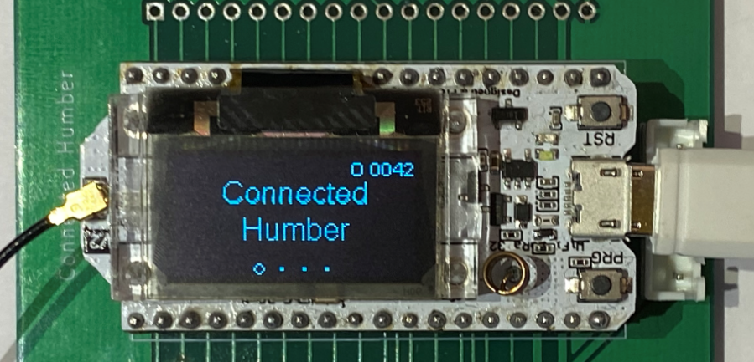

## Windows PC connection

With a PC, you should find that your PC will detect the sensor is connected and drivers that are required will be loaded automatically.

## Mac and Linux PC connection

In the case of the Mac or Linux PC, things are not quite so smooth. It might be that the sensor will work, but you may need to download and install a driver to make it work. You can find the drivers here:

www.silabs.com/products/development-tools/software/usb-to-uart-bridge-vcp-drivers

Then you may be asked to reboot your computer (shut it down and restart it). After the reboot you should find that you can connect your computer to the Arduino.

## Sending commands to the sensor

You send commands over the USB connection to the sensor using a program that takes commands that you type on your PC keyboard and sends them over the USB connection into sensor. The program also displays responses that come back from the sensor. You are going to use the serial monitor program in the Arduino IDE to do this.

## Installing the Arduino Interactive Development Environment (IDE)

The Arduino IDE is used to create and deploy programs to Arduino based devices. It also includes a serial monitor that can talk to devices that have been connected to the computer. You are only going to use that part of the program, so don’t worry if it seems a bit complicated, you are only going to use a tiny part of it. The IDE is a free download. You can find it here:

https://www.arduino.cc/en/Main/Software

There are versions of the Arduino IDE for Windows, Mac or Linux PC. The Arduino IDE works the same on all the different platforms. The only difference between the platforms is in how they manage the connection between the computer and the Arduino. All the connections use a USB cable that links a usb port on the computer the computer to the socket on the Heltec sensor board. However, the precise way that the usb port is managed differs for each of the computers.

Once you have installed the Arduino SDK you should start it running. You should see a display similar to the one shown below:

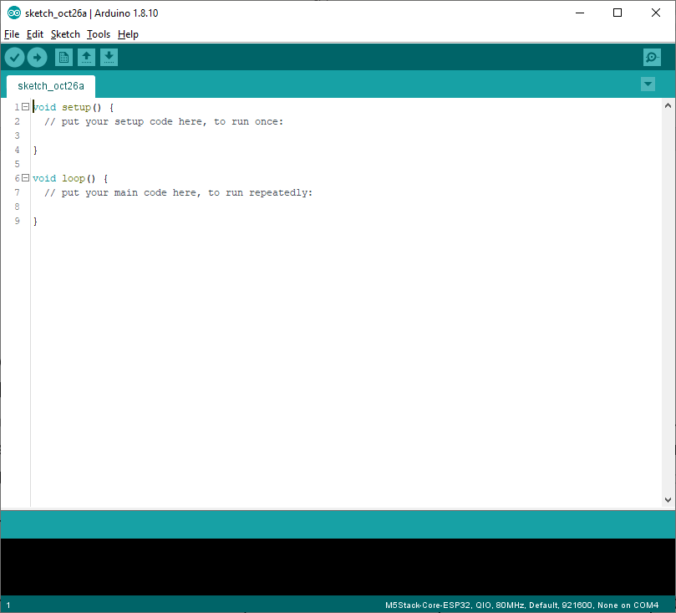

## Connecting the Arduino IDE to the sensor

The sensor connection to the PC is implemented as a *serial port* connection. A computer can have several devices connected to different serial ports. Before we can use the Arduino IDE to talk to the sensor we need to configure the IDE with the serial port that it is connected to. You do this using the Tools menu. If you open this you will see a menu drop down which contains a **Port:** element towards the bottom. If you move the mouse cursor over this element you will see an extra menu pop up which shows the serial ports that are presently connected on your computer. One of these will be your sensor connection.

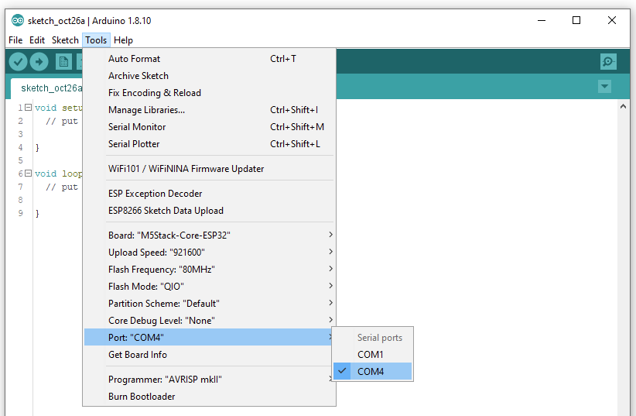

There might be only one serial port, in which case you can just select it. My PC has a built-in serial port which is called COM1. My sensor is connected to COM4 so I have selected that. If you see multiple com ports and you are not sure which is your sensor you can unplug your sensor and re-open the menu. The port that is no longer present is the one that your sensor is conned to.

If you don't find any serial ports displayed this means that your sensor is not connected to your PC. If this happens you can use the Windows PC Device Manager program to check to see if the serial drivers are working correctly.

Note that if you plug the sensor into a different USB port on your computer it might appear on a different COM port.

## Starting the Arduino Serial Monitor

Once you have your sensor connected to the PC you can start the Serial Monitor component of the Arduino SDK. You can find the serial monitor component of the Arduino SDK in the Tools menu.

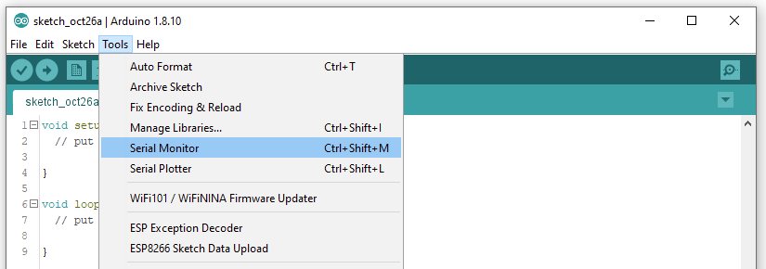

Select the Serial Monitor and open it. The Serial Monitor window will open:

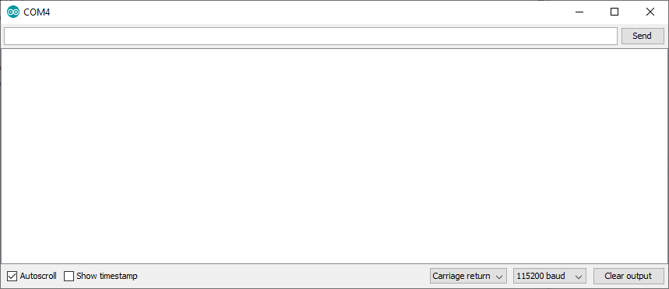

The next thing you must do is make sure that the *baud rate* is set correctly. The baud rate controls the speed at which data is transferred between the PC and the sensor. Both devices must operate at the same baud rate, otherwise the communication will be garbled. Open the control at the bottom of the serial monitor display and select the value 115200 from the options that appear, as shown below:

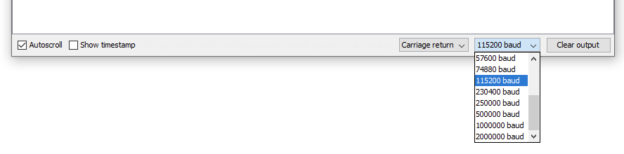

## Sending Sensor Commands

Once you have done this you can send commands to the sensor and view responses. The commands are sent as little packets of data which contain a single setting. The packet contents are enclosed in curly brackets. You can test the connection by sending an empty command, which should generate an error response.

Type an open and close bracket pair into the text box at the top of the Serial Monitor and then press the Send button.

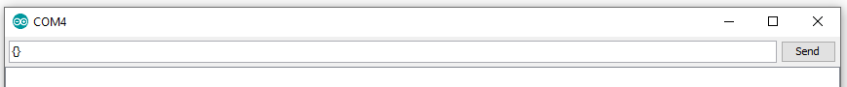

The sensor will read the commands and then generate a response as shown below. The response indicates that a command was received that does not contain a version number. If a command works, the response will have an error number of zero. A full list of all the error response values is given at the end of this document.

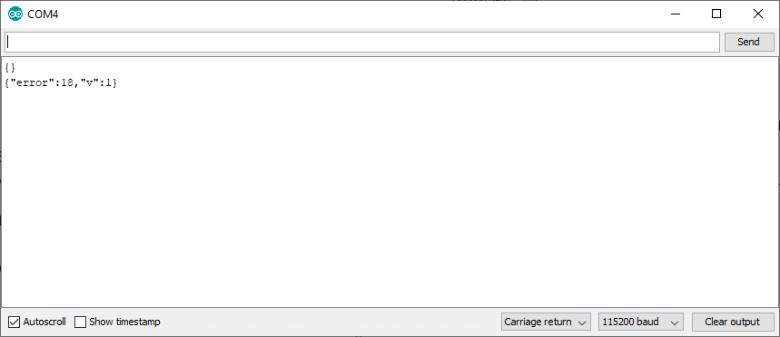

Sending data via WiFi

The sensor can send data to our database using either WiFi or LoRa.

If you have a local WiFi network in range we recommend using that as it is less likely to be affected by weather.

Alternatively you can configure the device to use LoRa and send the data via TTN but you need to check if you are able to connect to the LoRa network first. Range is affected by buildings in your line of site to a LoRa gateway.

Do not configure the sensor to send the data both ways.

Configuring for WiFi & MQTT

If using WiFi you will need to enable your sensor to use the local WiFi AND you will need to configure the MQTT settings.

{"v":1, "t" : "Sensor01", "c" : "wifi", "o" : "off"}

{"v":1, "t":"sensor01", "c" : "wifi", "o" : "ssid", "set":1, "val":"Your SSID"}

{"v":1, "t" : "sensor01", "c" : "wifi", "o" : "pwd", "set":1, "val":"password"}

{"v":1, "t" : "Sensor01", "c" : "wifi", "o" : "on"}

Configuring for LoRa

We will add your device to the Things Network and provide you with three pieces of information: Device Address, Network Session Key and Application EUI. We need to use the following commands to put these into the sensor using the serial communications link:

{"v":1, "t" : "sensor01", "c" : "lora", "o" : "state", "val" : "off"}

{"v":1, "t" : "sensor01", "c" : "lora", "o" : "access", "val":"abp"}

{"v":1, "t" : "sensor01", "c" : "lora", "o" : "abpdev", "val":"Device Address"}

{"v":1, "t" : "sensor01", "c" : "lora", "o" : "abpnwk", "val":"Network Session Key"}

{"v":1, "t" : "sensor01", "c" : "lora", "o" : "abpapp", "val":"Application EUI"}

{"v":1, "t" : "sensor01", "c" : "lora", "o" : "state", "val" : "on"}

The next step is to hard reset the device. You can do this by pressing the reset button on the device.

Setting the Reporting Frequency

By default the sensor sends its information once per minute but we require that to be changed to once every 6 minutes (360 seconds). This gives 10 readings per hour.

Use one of the following commands. You will hear the SDS011 sensor switch on and off. It turns on for 30 seconds, the sensor transmits the data and the SDS011 is then turned off for the remaining 330 seconds. This imporves the SDS011 lifespan by reducing wear on the fan bearings.

If using LoRa

{"v":1, "t" : "sensor01", "c" : "lora", "o" : "gap", "val":360}

If using WiFi

{"v":1, "t" : "sensor01", "c" : "mqtt", "o" : "gap", "val":360}

## Settings Storage

The settings for device are stored internally. The device can be configured for multiple WiFi networks, MQTT connections over secure or insecure sockets and LoRa connections authenticated by OTA (over the air) or ABP (access by personalisation).

It is also possible to enable or disable different hardware elements. It is possible to control WiFi, MQTT, LoRa, Real time clock and GPS connections in this way.

## Sending Commands

The host sends the device commands to read and write settings in the device. The configuration messages can be sent via the serial port or over an MQTT connection to a designated endpoint.

Every command will receive an acknowledgement. Note that not all configuration commands take effect immediately. Some require the device to be reset for the new setting to take effect. There is a remote command that can be used to force a reset of the device.

### Serial connection

You can use a terminal program (for example PuTTY or the Arduino IE Serial Monitor) to communicate with a sensor connected to a host computer via the serial port. The baud rate is 115200 and data is sent with with 8 data bits and no parity. A command can be terminated by a carriage return (0x0D) or a line feed (0x0A). Acknowledgements to each command are sent back to the serial port.

### MQTT connection

MQTT messages sent to the command topic will be interpreted as configuration commands. The command topic can be set the mqtt settings. The default command topic is:

airquality/commands

When a command has been performed the result is published to the mqtt publish topic. The default publish topic is:

airquality/data

## Command Structure

Each command is a json snippet with the following overall structure:

{"v":***ver***,"t":"***target***","c":"***family***","o":"***option***","val":***value***,"seq":***num***}

The **v** element of a command is the version of the protocol. The ***ver*** value gives the protocol version expressed as an integer. At present there is only one version of the protocol, this is version 1. If an incorrect version number is used by the host the device will reply with an error message which includes the version number of the protocol in use by that device.

The **t** element of a command identifies the target device for the command. Each device has a unique name. The ***target*** value gives the name of the target device. If this name does not match that in the device the command is rejected with an error. The only command that does not require a target value is the **getdevname** command which can be used to determine the name of a device. The default name of a device is **sensor01**.

The **c** element is the command family of the command. The ***family*** value gives the command family that this command is part of. There are four command families:

* node – commands to configure the node
* wifi – commands to configure wifi settings
* lora – commands to configure LoRa settings
* mqtt – commands to configure MQTT settings

The **o** element is the option of the command family that is in use. The ***option*** value of the command specifies the option from the command family which is being used.

The **val** element is provided to set the value of a given command option. The contents of ***value*** are provided to set the value of a given option. They may be numeric or a string. This element is optional for many commands. If the **val** element is left off the command is usually interpreted as a request to read the given setting.

The **seq** element is provided to allow the sender to uniquely identify a given command that has been issued. The contents of ***num*** are an integer sequence number which is set by the host. The reply message from the device will contain the same sequence number. This element is optional for all commands.

## Reply structure

Each command will receive a reply from the device. The reply will contain an error number which will be zero if the command was completed successfully. Appendix 1 of this document, Message Numbers gives the meaning of each error number.

The reply may also contain values that have been requested, along with a sequence number if one was given in the command.

## Sample Commands

### Sending a setting value

The following command sets the text to be displayed on the top line of the sensor. The command is being sent to the device **sensor01**. It uses the **spltop** option in the **node** family command.

{"v":1, "t":"sensor01", "c":"node", "o":"spltop", "val":"Hello Mum"}

The sensor will set the top line of the display to "Hello Mum". There is no sequence number, so the node replies with a message that indicates that the command was successful:

{"error":0}

### Reading a setting value

A host can read back the value of a setting by omitting the **val** element of the message:

{"v":1, "t":"sensor01", "c":"node", "o":"splbtm","seq":123}

This command contains a sequence number, which is echoed in the message from the sensor.

{"val":"Hello Mum","error":0,"seq":123}

# Device names

Each sensor can have a unique name. This means that multiple sensors could be connected to the same MQTT endpoint or shared serial connection and could be uniquely addressed.

The default name of a sensor is **sensor01** which is set when the sensor is powered up for the first time.

### Getting a device name

The node option **getdevname** gets the name of a sensor. It does not require a target device to be specified:

{"v":1, "c":"node", "o":"getdevname"}

The device will respond with its name:

{"nodename":"sensor01","error":0}

### Setting a device name

To set a device name you can use the **devname** command option:

{"v":1, "t":"sensor01", "c":"node", "o":"devname", "val":"Ferens"}

This would set the device name for the sensor to "Ferens".

Note that the device name is only used when processing incoming commands. It is independent of the MQTT sensor name. If you have no need to direct commands to different sensors you can leave the setting at **sensor01**.

## Protocol Versioning

Commands are pre-ceded by a version number. A given device uses a version of the protocol and will reject any messages with a different version number. You can find the protocol version in a device by using the ver command. This command does not require a version number or a target:

{"v":1, "c":"node", "o":"ver"}

The reply to this command is the version number of the command protocol in this sensor:

{"version":1,"error":0}

## Get Device Name

Gets the name of the device. This is the name that is used to send commands to the device. Note that this is not the MQTT or LoRa name of the device.

{"v":1, "c":"node", "o":"getdevname"}

The reply is the name of the device.

{"nodename":sensor01,"error":0}

## Set the Device Name

Sets the name of the device. The name of the device is used to identify commands that are to be performed by this device. It is **not** the same as the MQTT name of the device, which is set using an MQTT command.

{"v":1, "t":"sensor01","c":"node","o":"devname","val":"sensor02"}

The above command would change the name of the device from sensor01 to sensor02.

## MQTT Commands

This command family can be used to manage a connection to an MQTT server. The current value of the setting can be read back from the sensor by leaving out the “v” element.

### Set MQTT status

Enables or disables the MQTT system. When on the sensor will connect to the MQTT server on powerup using the stored connection settings. If the server is not found or the WiFi is disconnected the sensor will repeatedly retry the connection. The MQTT system can be on or off.

**The sensor must be reset if this setting is changed from off to on.**

{"v":1, "t" : "Sensor01", "c" : "mqtt", "o" : "state", "v" : "on"}

{"v":1, "t" : "Sensor01", "c" : "mqtt", "o" : "state", "v" : "off"}

### Force MQTT send

Forces the transmission of an MQTT message. If the air quality sensor is turned off it will be powered up and the results averaged before transmission. This transmission is made irrespective of any timed transmissions.

{"v":1, "t" : "Sensor01", "c" : "mqtt", "o" : "send"}

### Set MQTT transmission gap

You set the gap value to determine the rate at which a sensor will send readings to the network. For example, if you want to the sensor to send 10 readings per hour the gap between successive readings must be 6 minutes. The gap value is set in seconds, so for 10 readings per hour the gap must be set to 360 seconds.

The minimum gap between MQTT transmissions is 60 seconds and the maximum is 30000

{"v":1, "t" : "sensor01", "c" : "mqtt", "o" : "gap", "val":600}

### Set MQTT transmission retry time

If the MQTT transmission fails the sensor will retry the transmission. This command sets the time interval before the retry is attempted. The interval is given in seconds. The minimum interval is 1 second and the maximum is 3000

{"v":1, "t" : "sensor01", "c" : "mqtt", "o" : "retry", "val":20}

### Set MQTT publish topic

This sets the topic on the MQTT server to which the sensor will send reading values.

{"v":1, "t":"sensor01", "c":"mqtt", "o":"publish", "val":"sensor01/data"}

### Set MQTT command topic

This sets the topic on the MQTT server which the sensor will subscribe to for the reception of configuration commands.

{"v":1, "t":"sensor01", "c":"mqtt", "o":"subscribe", "val":"sensor01/commands"}

Commands will be acted on by the sensor upon receipt, and responses will be sent to the publish topic.

### Set MQTT device name

This sets the MQTT device name for this sensor. Note that this can be different from the command name. although both are set to “sensor01” when the device is initialised.

{"v":1, "t" : "sensor01", "c" : "mqtt", "o" : "id", "val":"sensor01" }

### Set the MQTT host address

This sets the address of the server to be used for MQTT.

{"v":1,"t":"sensor01", "c":"mqtt", "o":"host","val":"mqtt.connectedhumber.org"}

### Set the MQTT host username

This sets the username to be used on the MQTT host.

{"v":1, "t" : "sensor01", "c" : "mqtt", "o" : "user", "val":"username" }

### Set the MQTT host password

This sets the password to be used on the MQTT host.

{"v":1, "t" : "sensor01", "c" : "mqtt", "o" : "pwd", "val":"123456" }

### Set the MQTT host port

This sets the MQTT port to be used on the host. Note that there are different port numbers for secure sockets and open socket connections. Use secure sockets when connecting to an Azure IoT hub MQTT server:

* open sockets 1883
* secures sockets 8883

{"v":1, "t" : "sensor01", "c" : "mqtt", "o" : "port", "val":1883 }

## LoRa Commands

These commands can be used to configure and test a LoRa connection.

### Force LoRa send

This command forces the LoRa service to send a packet.

{"v":1, "t" : "Sensor01", "c" : "lora", "o" : "send"}

If the air quality sensor is turned off it will be powered up and the results averaged before transmission. This transmission is made irrespective of any timed transmissions.

### Force LoRa test

This command forces the LoRa service to send a test packet instantly. The most recently loaded values are sent immediately.

{"v":1, "t" : "Sensor01", "c" : "lora", "o" : "test"}

### Set LoRa status

Enables or disables the LoRa system. When on the sensor will connect to the LoRa gateway on powerup (if OTA authentication is being used) using the stored connection settings. The LoRa system can be on or off.

**The sensor must be reset if this setting is changed from off to on.**

{"v":1, "t" : "Sensor01", "c" : "lora", "o" : "state", "val" : "on"}

{"v":1, "t" : "Sensor01", "c" : "lora", "o" : "state", "val" : "off"}

### Set LoRa transmission gap

You set the gap value to determine the rate at which a sensor will send readings to the network. For example, if you want to the sensor to send 10 readings per hour the gap between successive readings must be 6 minutes. The gap value is set in seconds, so for 10 readings per hour the gap must be set to 360 seconds.

The minimum gap between transmissions is 60 seconds and the maximum is 30000.

{"v":1, "t" : "sensor01", "c" : "lora", "o" : "gap", "val":600}

### Setting LoRa for Authorisation by Personalisation (ABP)

When using LoRa "Authorisation By Personalisation" (ABP) a sensor must be configured with the application key, network key and device ID. These are supplied as sequences of HEX digits. They are normally obtained from The Things Network (TTN) device configuration page for the application within which the sensor is to be used.

{"v":1, "t" : "sensor01", "c" : "lora", "o" : "abpapp", "val":"AD7A768C296F2CA5C4C03E85862AE688"}

The above command sets the application key for a LoRa connection.

{"v":1, "t" : "sensor01", "c" : "lora", "o" : "abpnwk", "val":"117490D907331B077C5DAE9777FFE43C"}

The above command sets the network key for a LoRa connection.

{"v":1, "t" : "sensor01", "c" : "lora", "o" : "abpdev", "val":"26011BEE"}

The above command sets the device ID for a LoRa connection.

**The sensor must be reset if any of these settings are changed.**

## WiFi configuration

The sensor can store SSID and password details for up to five connections. When the sensor loses a network connection it will repeatedly search for connections that it knows about.

### Turn WiFi on and off

When the WiFi is turned off the sensor will not search for stations and any services that require a WiFi connection (for example MQTT) will not be started. There are two commands to turn the WiFi on and off:

{"v":1, "t" : "Sensor01", "c" : "wifi", "o" : "on"}

{"v":1, "t" : "Sensor01", "c" : "wifi", "o" : "off"}

### Set WiFi SSID

Each wifi setting slot is identified by a value in the range 0 to 4. Attempts to set a value in a slot outside this range will result in an error. The setting in location 0 is initialised to a Connect Humber configuration connection.

{"v":1, "t":"sensor01", "c" : "wifi", "o" : "ssid", "set":1, "val":"host"}

The above command would set the ssid for slot 1 to be **host**.

### Set WiFi password

Each wifi setting also has a password which can be set:

{"v":1, "t" : "sensor01", "c" : "wifi", "o" : "pwd", "set":1, "val":"password"}

The above command would set the password for slot 1 to be **password**.

**Note that it is not possible to read back the value of a WiFi password.**

## Node settings

The node settings can be used to configure a range of elements on the device. They can also trigger actions including reset the device and clear the device settings.

### Get the protocol version

This command returns the version number of the protocol implemented by this sensor.

{"v":1, "c" : "node", "o" : "ver"}

Note that this command does not need a target device to be specified.

### Get the device command name

This command returns the device name.

{"v":1, "c" : "node", "o" : "getdevname"}

## Reset the device

This command resets the device. It is the equivalent of turning the device of and then on again. It has no effect on the contents of settings.

{"v":1, "t" : "sensor01", "c" : "node", "o" : "reset"}

## Clear the device settings

This command clears all the device settings and returns them to the original values.

{"v":1, "t" : "sensor01", "c" : "node", "o" : "clear"}

**Note that there is no confirmation dialog for this command, the settings will be cleared and the device then reset.**

## Set the device command name

This command sets the device name for use in commands. The device name is the name that will serve as the target for commands.

{"v":1, "t" : "sensor01", "c" : "node", "o" : "devname", "val":"sensor01"}

## Set the banner display

The sensor can display a two-line banner as it is operating. This can be used to identify the device or allow a remote host to display messages on the sensor screen. There are two commands that can be used to set the top and bottom lines of this display:

{"v":1, "t" : "sensor01", "c" : "node", "o" : "spltop", "val":"Connected"}

{"v":1, "t" : "sensor01", "c" : "node", "o" : "splbtm", "val":"Humber"}

The two lines will set the top and bottom elements of the banner display.

### Set the air quality sensor warmup time

The air quality sensor is switched off between readings. This reduces wear on the sensor and reduces the amount of airflow through the sensor and the amount of dust that accumulates in it. This command allows the setting of the number of seconds before a reading is required that the sensor is powered up. If the warmup time is made greater than the gap between readings the sensor will be turned on continuously.

{"v":1, "t" : "sensor01", "c" : "node", "o" : "warmup", "val":30}

The sensor is warmed up for LoRa or MQTT transmissions, depending on which is being delivered sooner. The interval between transmissions (also described as the gap) can be set for LoRa by using commands described in the sections "Set Lora transmission gap" and "Set MQTT transmission gap".

### Set the GPS receiver state

The sensor can be fitted with a GPS sensor that allows MQTT readings to be tagged with latitude and longitude values. If the GPS is not switched on sensor will not try to connect to a GPS receiver.

{"v":1, "t" : "Sensor01", "c" : "gps", "o" : "state", "val" : "on"}

{"v":1, "t" : "Sensor01", "c" : "gps", "o" : "state", "val" : "off"}

### Set the Real Time Clock state

The sensor can be fitted with a real time clock chip that allows MQTT readings to be tagged with date and time. If the RTC is not switched on the sensor will not try to connect to a real time clock.

### Set the display state

The sensor can be forced to display readings if neither MQTT or LoRa are enabled. In this state the air quality sensor runs permanently and the displays are always updated. Display state should only be switched on when you are testing the air quality and environmental sensors.

{"v":1, "t" : "Sensor01", "c" : "display", "o" : "state", "val" : "on"}

{"v":1, "t" : "Sensor01", "c" : "display", "o" : "state", "val" : "off"}

## Message Numbers

If the contents of a command are inconsistent the value in the reply element in the message can be used to determine the error state. These are the message numbers and their meanings.

#define WORKED_OK 0  
#define NUMERIC_VALUE_NOT_AN_INTEGER 1  
#define NUMERIC_VALUE_BELOW_MINIMUM 2  
#define NUMERIC_VALUE_ABOVE_MAXIMUM 3  
#define INVALID_HEX_DIGIT_IN_VALUE 4  
#define INCOMING_HEX_VALUE_TOO_BIG_FOR_BUFFER 5  
#define VALUE_MISSING_OR_NOT_A_STRING 6  
#define INCOMING_HEX_VALUE_IS_THE_WRONG_LENGTH 7  
#define INVALID_OR_MISSING_TARGET_IN_RECEIVED_COMMAND 8  
#define COMMAND_FOR_DIFFERENT_TARGET 9  
#define INVALID_OR_MISSING_DEVICE_NAME 10  
#define INVALID_DEVICE_NAME_FOR_MQTT_ON 11  
#define STRING_VALUE_MISSING_OR_NOT_STRING 13  
#define STRING_VALUE_TOO_LONG 14  
#define INVALID_LORA_ACCESS_SETTING 15  
#define INVALID_COMMAND_NAME 16  
#define JSON_COMMAND_COULD_NOT_BE_PARSED 17  
#define JSON_COMMAND_MISSING_VERSION 18  
#define JSON_COMMAND_MISSING_COMMAND 19  
#define JSON_COMMAND_MISSING_OPTION 20  
#define INVALID_MQTT_STATUS_SETTING 21  
#define INVALID_LORA_STATUS_SETTING 22  
#define MISSING_WIFI_SETTING_NUMBER 23  
#define INVALID_WIFI_SETTING_NUMBER 24  
#define INVALID_GPS_STATUS_SETTING 25  
#define INVALID_RTC_STATUS_SETTING 26  
#define INVALID_DISPLAY_STATUS_SETTING 27